Web Application of caBench-to Bedside v3.1
Design Document

Document Change History
Version Number | Date | Contributor | Description
V1.0 | October 1, 2009 | Washington University/Persistent Systems Ltd/National cancer Institute | Draft



This is a U.S. Government work. October 26, 2009

Development Teams
Development | Design document | Program Management
Chandrakant Talele¹ | Chandrakant Talele¹ | Dr. Rakesh Nagarajan²
Chetan Patil¹ | Chetan Patil¹ | Srikanth Adiga^{1, 2}
Chetan Pundhir¹ | Chetan Pundhir¹ | Chandrakant Talele¹
Deepak Shingan¹ | Deepak Shingan¹ | Mukesh Sharma²
Gaurav Mehta¹ | Gaurav Mehta¹ | Stephen A. Goldstein³
Pallavi Mistry¹ | Pallavi Mistry¹
Rajesh Vyas¹ | Rajesh Vyas¹
¹Persistent Systems Limited | ²Washington University
³Sapient Corporation | ⁴Capability Plus Solutions

Contacts and Support
Training contact | cab2bsupport@bmi.wustl.edu
Customer support contact | cab2bsupport@bmi.wustl.edu

Copyright and License Information
Copyright Notice. Copyright 2005 “School of Medicine, Washington University in St. Louis” (“caBIG® Participant”). cancer Bench-to-Bedside was created with NCI funding and is part of the caBIG® initiative. The software subject to this notice and license includes both human readable source code form and machine readable, binary, object code form (the “caBIG® Software”).
This caBIG® Software License (the “License”) is between caBIG® Participant and You. “You (or “Your”) shall mean a person or an entity, and all other entities that control, are controlled by, or are under common control with the entity. “Control” for purposes of this definition means (i) the direct or indirect power to cause the direction or management of such entity, whether by contract or otherwise, or (ii) ownership of fifty percent (50%) or more of the outstanding shares, or (iii) beneficial ownership of such entity.
License. Provided that You agree to the conditions described below, caBIG® Participant grants You a non-exclusive, worldwide, perpetual, fully-paid-up, no-charge, irrevocable, transferable and royalty-free right and license in its rights in the caBIG® Software, including any copyright or patent rights therein that may be infringed by the making, using, selling, offering for sale, or importing of caBIG® Software, to (i) use, install, access, operate, execute, reproduce, copy, modify, translate, market, publicly display, publicly perform, and prepare derivative works of the caBIG® Software; (ii) make, have made, use, practice, sell, and offer for sale, and/or otherwise dispose of caBIG® Software (or portions thereof); (iii) distribute and have distributed to and by third parties the caBIG® Software and any modifications and derivative works thereof; and (iv) sublicense the foregoing rights set out in (i), (ii) and (iii) to third parties, including the right to license such rights to further third parties. For sake of clarity, and not by way of limitation, caBIG® Participant shall have no right of accounting or right of payment from You or Your sublicensees for the rights granted under this License. This License is granted at no charge to You. Your downloading, copying, modifying, displaying, distributing or use of caBIG® Software constitutes acceptance of all of the terms and conditions of this Agreement. If you do not agree to such terms and conditions, you have no right to download, copy, modify, display, distribute or use the caBIG® Software.
- Your redistributions of the source code for the caBIG® Software must retain the above copyright notice, this list of conditions and the disclaimer and limitation of liability of Article 6 below. Your redistributions in object code form must reproduce the above copyright notice, this list of conditions and the disclaimer of Article 6 in the documentation and/or other materials provided with the distribution, if any.
- Your end-user documentation included with the redistribution, if any, must include the following acknowledgment: “This product includes software developed by School of Medicine, Washington University in St. Louis.” If You do not include such end-user documentation, You shall include this acknowledgment in the caBIG® Software itself, wherever such third-party acknowledgments normally appear.
- You may not use the names “School of Medicine, Washington University in St. Louis”, “The National Cancer Institute”, “NCI”, “Cancer Bioinformatics Grid” or “caBIG®” to endorse or promote products derived from this caBIG® Software. This License does not authorize You to use any trademarks, service marks, trade names, logos or product names of either caBIG® Participant, NCI or caBIG®, except as required to comply with the terms of this License.
- For sake of clarity, and not by way of limitation, You may incorporate this caBIG® Software into Your proprietary programs and into any third party proprietary programs. However, if You incorporate the caBIG® Software into third party proprietary programs, You agree that You are solely responsible for obtaining any permission from such third parties required to incorporate the caBIG® Software into such third party proprietary programs and for informing Your sublicensees, including without limitation Your end-users, of their obligation to secure any required permissions from such third parties before incorporating the caBIG® Software into such third party proprietary software programs. In the event that You fail to obtain such permissions, You agree to indemnify caBIG® Participant for any claims against caBIG® Participant by such third parties, except to the extent prohibited by law, resulting from Your failure to obtain such permissions.
- For sake of clarity, and not by way of limitation, You may add Your own copyright statement to Your modifications and to the derivative works, and You may provide additional or different license terms and conditions in Your sublicenses of modifications of the caBIG® Software, or any derivative works of the caBIG® Software as a whole, provided Your use, reproduction, and distribution of the Work otherwise complies with the conditions stated in this License.
- THIS caBIG® SOFTWARE IS PROVIDED "AS IS" AND ANY EXPRESSED OR IMPLIED WARRANTIES (INCLUDING, BUT NOT LIMITED TO, THE IMPLIED WARRANTIES OF MERCHANTABILITY, NON-INFRINGEMENT AND FITNESS FOR A PARTICULAR PURPOSE) ARE DISCLAIMED. IN NO EVENT SHALL THE SCHOOL OF MEDICINE, WASHINGTON UNIVERSITY IN ST. LOUIS OR ITS AFFILIATES BE LIABLE FOR ANY DIRECT, INDIRECT, INCIDENTAL, SPECIAL, EXEMPLARY, OR CONSEQUENTIAL DAMAGES (INCLUDING, BUT NOT LIMITED TO, PROCUREMENT OF SUBSTITUTE GOODS OR SERVICES; LOSS OF USE, DATA, OR PROFITS; OR BUSINESS INTERRUPTION) HOWEVER CAUSED AND ON ANY THEORY OF LIABILITY, WHETHER IN CONTRACT, STRICT LIABILITY, OR TORT (INCLUDING NEGLIGENCE OR OTHERWISE) ARISING IN ANY WAY OUT OF THE USE OF THIS caBIG® SOFTWARE, EVEN IF ADVISED OF THE POSSIBILITY OF SUCH DAMAGE.
Contents
Chapter 1 Introduction 1
Need for Web Application 1
Chapter 2 High Level Architecture 2
Overview 2
Relationship to caB2B Thick Client 3
MVC with Struts 3
User Interface Design 4
Standards for HTML/JSP Page Design 5
Standards for Cascading Style Sheets (CSS) 6
Standards for Java Script 7
AJAX Call Approach 7
Chapter 3 View/Edit Service Instances 9
Requirement 9
Design 9
Data-Model Layer 9
Controller 10
View 10
Chapter 4 Add Limit 11
Requirement 11
Design: Server Side Components 11
Design: Client Side Components 11
Functionality 13
Chapter 5 View Results 14
Requirements 14
Design 14
QueryExecutionHandler 17
Chapter 6 Query Dashboard 20
Overview 20
Design 21
Background Query Execution 22
Chapter 7 Exception Handling 24
Overview 24
Exception Handling Framework 24
Action Classes 24
JSP pages 24
Index 26

Introduction
The caB2B web application is a version of caB2B that is geared towards ease-of-use and it targets users who do not have detailed knowledge of the underlying data models for caBIG applications. It exposes a subset of caB2B features via a web interface, as opposed to caB2B application (a thick client-server application) where client is a desktop application implemented in Java Swing. The underlying caB2B server will service both the caB2B desktop client and the web application.

Need for Web Application
Although caB2B is a very powerful application, it has limitations in that it is a thick client, which requires setup and configuration on user machines. In addition, it may require a slightly different setup process on differing architectures.
Besides this, due to the overall design/workflow of application, potential caB2B users need to be acquainted with certain technical caGrid information and terminologies in order to use the application.
The caB2B web application helps in accessing data from caGrid services, acting as a single access point for less sophisticated users. It is designed with an extremely user friendly web interface that helps end users to query any available caGrid service, simplifying the grid terminologies and eliminating the model-centric view. A user with little or no knowledge of the caGrid is able to use the application easily. It only needs administrator’s interventions at the start to identify and define useful queries as per user’s need.

High Level Architecture

Overview
Based on the requirement of the caB2B web application, we have used the Struts framework that suits and satisfies our underlying needs as follows.
- Struts is more widely used and supported than any other framework for J2EE enterprise web applications
- Struts provide all the features that are needed by our application and are extensible.
- Learning and expertise of other frameworks (like spring) which may provide same functionalities and has more features will take more time.
The caB2B web application is based on the MVC design pattern, as shown below. The View layer includes client-side view technologies, including HTML, CSS and JavaScript. For dynamic generation of view components, we are using JSP templates. The view layer does not include any business logic or control, which is instead hosted in the Controller and/or Model layers. This maintain loose coupling between different layers and ensure the application is modular and maintainable.
Figure 1 MVC Design Pattern
The controller layer exists as a set of Struts Action classes. These Action classes have code only for controlling the flow of the action, while the Model layer defines the business logic. Model layer interacts with the databases, grid services, and other data stores. Thus, the code for accessing, and manipulating the data layer is encapsulated by the Model layer. The project has this code in the form of EJBs and BizLogic Java classes.
Following diagram shows the high-level architecture of web application. Several key things to note in the above architecture are:
- The filter class (ApplicationFilter.java) ensures that all requests are redirected to home page after session timeout.
- In case of query execution, an action class invokes a cab2b web facade that in turn calls the business delegation layer. This layer invokes appropriate business logic in caB2B business layer that executes the query.
- caB2B Web Application is deployed as a web module of EAR so that it can reuse all features supported by caB2B server. Admin module is also deployed as a web module.
- caB2B EJB invocations only delegates (does not contain any logic) to Business Layer. If Business Layer is deployed within EAR (as a JAR module), this layer could be accessed by web modules deployed within EAR.
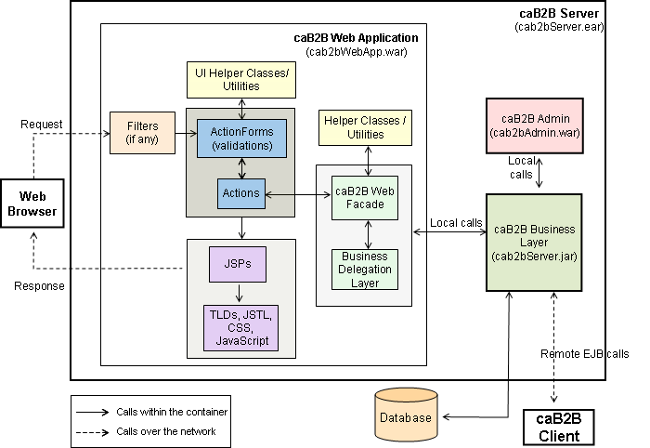
Figure 2 High Level Architecture

Relationship to caB2B Thick Client
- caB2B client is a Swing based application, whereas caB2B Web Application is based on MVC architecture using Struts. Hence, as far as UI implementation is concerned, they do not share any substantial code.
- caB2B introduces any functionality through its Business layer. This could be always exposed to client as Remote EJB interfaces.
- caB2B client interacts with server through Remote EJB calls. These EJB calls are initially done using JNDI/HTTP, EJB/HTTP.

MVC with Struts
The Struts framework is used to support MVC design pattern. The following standards are followed while using Struts:
- All the string resources to be shown on view layer are managed under ApplicationResources.properties file. This holds true for any text shown on JSPs, JavaScript alerts or backend error messages. Struts bean message tag is used for displaying these resources on pages.
- HTML forms are represented using appropriate ActionForm class. For example, for the Login form on login page, an action form, LoginForm is created. LoginForm captures form parameters, username and password for the controller action and on some validation error, the control is redirected back to login page with the form fields, with username and password automatically filled. This pre-filling is achieved by using Struts html tags. HTML forms are avoided for basic HTML forms having, for example, single form field that does not require any validation or auto filling in general.
- Errors are set in action classes using ActionError, and ActionErrors classes. For messages, ActionMessage, and ActionMessages classes are used. Each error or general message maps to an appropriate key in the ApplicationResources.properties file.
No business logic is present on JSP pages. JSP layer calls controller layer (Action classes) which interact with BizLogic classes to obtain the response. To make the response free of business objects, DVO classes are used wherever required. DVO classes acts as a bridge for displaying business objects on view layer. Using them for UI component helps in making design modular and easily extensible. Changes in business objects do not affect the view layer and view specific characteristics can be easily modeled and manipulated by DVO objects.

User Interface Design
The UI design of caB2B web application is extremely friendly, modular and compact. To meet these goals, the following approach is followed:
- The layout of all the pages is controlled via CSS by using DIV based layout instead of using traditional table based layouts.
- DIV based layout significantly reduces the markup tags in the page and makes page loading comparatively faster. In addition, user need not wait for the loading of entire page layout before anything is visible on the page as DIV based layouts makes parts of pages to be visible as soon as they are loaded.
- DIV design allows different sections of the page to be placed independently of each other. This means the most important sections of the page can be placed at the top in the HTML code so that they become visible immediately. In addition, if the page is viewed on some unsupported browser, the page though may not be viewed properly laid out will show the most important parts at the top.
- As most of the view aspects are controlled using CSS, we have better control on the view not only for a particular page but also for the entire application from a single point. Thus, we can have features like having different view for different media, rich UI for screen and a very basic printer friendly version for printers. Other features like UI skins and browser specific view can also be easily implemented and controlled.
- AJAX calls are used for making changes to the sections of the page without reloading the entire page. Therefore, we are able to initiate requests to the server and show the results on the page without causing any page reload.
- JavaScript is used for client side validation. Alerts will not be used for notification of multiple validation errors. Instead, all validation errors are shown on screen at once in appropriate color.
- Rich DHTML controls are used at appropriate places to make pages user friendly and uncluttered.

Standards for HTML/JSP Page Design
- Each HTML/JSP page name has all the letters in lowercase.
- The page name should represent the actual view component it is supposed to display.
- To keep JSP pages scriptlets free, Expression Language (EL - $) and Struts html, bean and logic tag libraries are used.
- Page components that are reusable are kept in individual JSP pages and are included in parent JSP pages whenever needed. For example, since page header, footer and left panels are required at multiple places, they are kept under individual JSP files, heder.jsp, footer.jsp, and leftpanel.jsp, respectively. These JSP are included at appropriate places in parent JSP files.
- No text resource should be present in JSP pages. Keeping this in view, all the text resources are placed in ApplicationResources.properties file and accessed on pages using Struts bean message tag. To keep the properties file clean, compact and standard, the following approach is followed:
  - The file is organized into sections so that resources can be easily categorized and organized.
  - Text resources common to multiple pages are kept under the section titled ‘##Common’.
  - Text resources are defined in lowercase. This standard is followed throughout.
  - Text resources corresponding to individual pages are kept under their separate section. For example, ‘##Left Panel Page’
  - Standard nomenclature scheme is followed. While placing properties in the properties file, adjectives should be prevented and nouns should be used. For better organization, all the properties start with a more basic class it represents, separated by dot, then any subclass, if necessary, followed by dot and then the actual property. For example, links on JSP pages are represented in properties file starting with the class link. Thus, the link for caBIG Home is represented as link.home.cabig=caBIG Home. This type of standard naming scheme helps in very well organization of properties file.
  - A separate section is kept for placing unexpected error resources under section, ‘##Fatal Error Page’. As all unexpected errors are supposed to be displayed by the global exception page, so, these are kept under the fatal error page section.
  - All the images used on pages have their ALT text defined. ALT text is also accessed from properties file.
  - All the JSP have only necessary taglib imports.
  - Each page except the global failure page have the definition for its error page as, <%@ page errorPage="failure.jsp" %>. The global exception page is declared as an error page, using, <%@ page isErrorPage="true" %>.

Standards for Cascading Style Sheets (CSS)
Cascading Style Sheets (CSS) are used for page layouts and style. The following standards are followed while using CSS
- CSS file name has all the letters in lowercase.
- Page layout is maintained using CSS. Tables are prevented as far as possible.
- Styles and layouts that are common to multiple pages are defined and categorized under a separate CSS file, common.css. For example, buttons, links, header, footer, etc. are components that are used in multiple pages. It helps in central control of style and layout of entire application’s common elements.
- Styles and layouts corresponding to individual page are kept in separate CSS file for the page. For example, CSS file for the page home.jsp is home.css. Individual pages also require common styles from common.css. So, common.css is imported in the page specific CSS file itself instead of importing it explicitly in the JSP page.
- Styles or layouts that may be applied to multiple elements in a page are represented as classes while those applicable to single elements are specified as ids. For example, in common.css, .label represents style class for all the labels in the application. Thus, a single change in this style class will change the style of all the labels at once.
- For page layout, CSS is designed by identifying different section of the page, such as left-panel, center-panel, right-panel, etc, and then defining their layouts.
- All the form elements, like, buttons, links, select boxes, etc, are defined as a CSS class in common.css. Thus every aspect of form elements, like height, width, color, positioning, etc., can be controlled from common.css.
- Separate class is maintained for errors and normal messages in common.css.
- All the CSS elements are named in lowercase.
- CSS names should represent nouns and adjectives should never be used. For example, a text representing a heading in a section can be given class name heading instead of giving inappropriate and ambiguous class name, like fontBlkBlb (just because font color is black and it is bold). A font that is black in color at a particular time may be required to change to green and then using a class name like fontBlkBlb for such elements will certainly reflect poor nomenclature. Such names are also difficult to remember and manage. If you know that you have to apply class to a button and its name cannot be other than button itself, then, this will be obvious.
- Layout widths are represented in percentages. This practice is followed so that the entire page is displayed within viewport at once irrespective of user’s browser screen size. This helps in preventing undesired horizontal scroll bar.
- In some places, inline styles are occasionally used. The objective is that the style that corresponds to an individual page and need not require change in future with respect to view or layout can be placed as inline style and thus most obvious styles are present in external page specific CSS file.
- Usage of browser specific styles is prevented

Standards for Java Script
JavaScript is used for validations and other client side scripting needs. The following standards are followed while using JavaScript.
- JavaScript common to multiple pages or JavaScript corresponding to utilities, like calendar, etc. are kept in external JS files. Only page specific JavaScript is kept in individual files.
- Small page specific scripts are defined inline within page body contents. Only bigger page specific scripts are kept in header section of the page. This helps in better management and control.
- JavaScript files are named with all letters in lowercase.
- An external JS file for a specific page, for example addlimit.jsp is named as addlimit.js. Page specific external JS is used here because of too big size of the script. Keeping a very large JavaScript In head section of the page should be prevented.
- Browser specific JavaScript is prevented in general and if used is surrounded by appropriate checks to prevent JavaScript errors in any browser which is not supporting the script.
- Common utility scripts are kept in utils.js file. Similarly, common validation scripts are kept in validator.js file.

AJAX Call Approach
AJAX is used to make the user interface more intuitive and friendly. AJAX allows individual sections of pages to be updated using response from server without causing the entire page reload in browser. Thus, user can navigate within the pages seamlessly without having any knowledge that the live data from server is fetched as and when needed. The following approach is followed for AJAX calls:
- JavaScript code to create browser specific XML HTTP Object for making AJAX calls is kept in the external JS file ajax.js.
- Another method processAJAXRequest (requestURL, responseReceiver, hideLoadingImage, callbackFunction) is also defined in the ajax.js file. This method acts as the gateway for all AJAX calls. Developer can easily make AJAX calls from any page just by importing the ajax.js file and calling the processAJAXRequest method with the appropriate parameters. Here, requestURL is the URL of the resource to be called through AJAX and responseReceiver represents the id of the HTML DIV on the HTML/JSP page where the response of the call should be placed. If responseReceiver parameter is not set, then a server call is initiated but it is expected that no response should be shown on the UI for that call. The hideLoadingImage parameter causes the loading image to be disabled for the AJAX call. The callbackFunction parameter is the reference of the function that should be called after successful completion of the AJAX call. In general, an action URL is passed as requestURL. The action after completing its processing calls some JSP component that is parsed and the resulting HTML is returned back as response. This HTML is set within the HTML DIV represented by the responseReceiver.
- Since results fetching from server may take some time, therefore, code in processAJAXRequest method also ensures that a loading image is shown just before firing AJAX call and is shown until response is received. Display of loading image can be controlled using the hideLoadingImage parameter in the processAJAXRequest method.
- If any exception occurs while processing the request, then, processAJAXRequest method sets the appropriate error message in the responseReceiver HTML DIV.
- If session timeout has occurred and an AJAX call is made, then, provisions in processAJAXRequest method ensures that session timeout message is shown and control of page is redirected to home page. This is handled by passing all requests to filter class, ApplicationFilter that checks session status before directing control to actual requestURL. Thus, in case of session timeout, control is never forwarded to the request URL. Instead, a response status code indicating session timeout is sent back. This response code is checked in processAJAXRequest method and if found, the, session timeout message is shown.
Response for most AJAX calls is HTML that is obtained by parsing of some JSP templates. These JSP templates represent certain sections in some parent JSP page. For example, searchresultspanel.jsp represents the spreadsheet portion of the search results page. Thus, main page is the search results page and within it, serchresultspanel.jsp is included as the page loads first time and for AJAX calls initiated on change in the ‘Results For’ combo on search results page.

View/Edit Service Instances

Requirement
Requirements for this feature are summarized briefly below
- Show the instances only for the application selected in the dropdown on the query page.
- Allow user to configure service instances to be queried.
- The service instances configured by admin should be shown selected for anonymous user.
- Persist users selection into database
- Show users previously selected instances at the top.

Design
For completing above requirements, implementation has been divided at three different levels viz. Data-Model, view and controller. Data-Model layer is handled at server level in caB2B server application while View and controller are the part of caB2BWebApplication code. Following are summarized information about the classes used for executing requirements.

Data-Model Layer
- UserInterface.java
Interface for representing all basic user information. For getting service instances for the user, Collection<ServiceURLInterface> getServiceURLCollection() is the most important method which returns all services configured for the user irrespective of any model-group or entity-group.

- ServiceURLOperations.java
This class performs operations related to the Service URLs and provides some very important methods that directly gets data from database and returns all required information about any Service URL.

- ModelGroupOperations.java
This class performs operations related to the Model Group and provides some very important methods that directly gets data from database and returns all required information about any Model Group.

- SaveServiceInstancesBizLogic.java
It is the biz logic for updating service instance for the current user.

- updateServiceInstanceSettings
The above method is the main and only one important method of this class. This method updates user selected service instances in User object as configured and all other services as not configured. If User==ANONYMOUS any changes made by user do not get persist in database otherwise for all valid users changes persist.

- ApplicationBizLogic.java:
This class contains logic for loading application related things and gives information about Service instances for given application name.

Controller
- DisplayServiceInstancesAction.java
This action class shows service instances. On successful completion, it sets service instances and selected model group name as request object and redirects to next page.

- SaveServiceInstanceAction
This action class is responsible for executing save-service operation for current user.

View
- serviceinstances.jsp
The file contains input validation logic and UI design (view) part. The page is generated when a call is made to DisplayServiceInstances.do action and when user clicks on Database to Search link from home page. When user selects/deselects some service instances and click on “Save Settings” button the control is forwarded to SaveServiceInstances.do action.

- serviceinstances.css
The file contains layout style sheet classes and defines important UI design parameters for serviceinstances.jsp file.

- utils.js
The file contains useful java script functions that can be used throughout application.

Add Limit

Requirement
Admin saves the queries using Admin Web Module. While saving query, admin defines limits on some of the attributes in associated classes while some attributes may be left as they are, without any limit. These saved queries are visible in the caB2B Web Application for execution. On the home page, user can see all the saved queries as links. On clicking any saved query, user should be displayed the Add Limit page where he/she can define limits on the query before execution. The form displayed here should be same as used by admin while defining and saving limit on query.

Design: Server Side Components
- ApplicationFilter.java
Used for checking the session validity for each request in the application.
- AddLimitAction.java
This action class is called from home page and add limit page. It is used to call the code for generating dynamic HTML form for adding limit on a saved query. This class is also called from home page for forwarding request to addlimit.jsp page.
- DisplaySavedSearchesAction.java
This action class calls the code to access saved searches corresponding to model groups selected by the user. Currently, saved searches are displayed on home page and add limits page. So, depending on the desired page, this action class redirects to the page with the list of saved queries to display.
- AddLimitHTMLGeneratorBizLogic.java
This class is used for dynamic generation of add limit HTML form corresponding to a query.
- ModelGroupDVO.java
This DVO class represents the model groups select box on the home page and is used while displaying them and also to maintain the model group selection state of user while navigating through the application.
- SavedSearchComparator.java
This class is used to sort the list of saved queries to be displayed.
- AddLimitConstants.java
This constant file contains the constants used specifically for the add limit functionality in AddLimitHTMLGeneratorBizLogic.java.
- Constants.java
This is the standard application wide constant file.

Design: Client Side Components

JSP/HTML Pages
- header.jsp
Used for displaying the application header bar.
- savedsearches.jsp
This JSP page has the code for displaying saved searches. It receives the saved searches list to display from DisplaySavedSearchesAction.java. Since, saved searches are supposed to be displayed both on the home page and the add limits page, therefore, its code is kept in a separate JSP file and included at both pages.
- addlimit.jsp
This JSP page displays the add limit form. Saved queries are shown in the left panel on this page. For a particular selected query, the add limit form is displayed.
- calendar.html
This blank html file is used by the calendar.js for creation of calendar HTML to be shown on the add limit page’s date fields.
- footer.jsp
Use for displaying the application footer bar.

CSS files
- common.css
This CSS file contains styles commonly required at many pages, like link style.
- savedsearches.css
This CSS file contains styles for panel displayed for saved searches.
- addlimit.css
This CSS file contains style for the dynamically generated HTML form for adding limits on query.

JavaScript files
- ajax.js
This file contains JavaScript code for making AJAX calls. The processAJAXRequest method is used for making AJAX calls from JSP pages.
- addlimit.js
This file contains JavaScript code for proper display of the add limit form. For example, on selecting ‘Between’ condition for a limit, two text boxes should be shown while on selecting ‘In’ condition, only one text box should be shown. These events are handled in this JS file.
- calendar.js
This file contains JavaScript code for generating HTML for calendar display. It uses the blank calendar.html file for writing the generated calendar HTML and this HTML file is shown whenever calendar is needed for date fields.

Functionality
The client and server side components interact to display the add limit page as:
- User selects a model group from the data type select box on home page. Saved queries corresponding to the selected model group are shown in the saved queries panel.
- User clicks on any query from the list. This results in a browser request for the AddLimitAction.java class.
- This browser request is captured by ApplicationFilter.java that checks the user session validity. If the session is not valid, then, control is forwarded back to the home page. If the session is valid, then, the control is directed to the AddLimitAction.java class.
- From AddLimitAction.java, the control is directly transferred to the addlimit.jsp page. The addlimit.jsp page has two sections. In the left pane, list of saved queries are shown. Depending on the selection of query on the home page, same query is shown as selected.
- As soon as the page loads with the selected query, an AJAX call is made to the AddLimitAction.java with the id of the selected query as the parameter.
- Using the query Id, the query object is created and this query is passed to the AddLimitHTMLGenerator.java class which parses the attributes of the query to dynamically generate the HTML for the add limits page.
- The HTML returned from the AddLimitHTMLGenerator.java class is written into the ServletOutputStream and hence captured and displayed as response of the AJAX call by the browser.
- The HTML form returned by the AddLimitHTMLGenerator.java has the dynamically generated form elements. Their names are also dynamic with certain naming conventions.
- The addlimit.js is the JavaScript file having methods to ensure that proper changes in form occur on various events on form elements. For example, on selection of ‘Is’ parameter for a limit, the two text boxes shown for ‘Between’ limit should change to one.
- As conditions are defined on the form, the code in addlimit.js automatically creates a query string representing the updated limits. If no condition is defined, then, this string remains empty and thus it is used to enforce user to define limit on the form before query execution. Thus, if user does not define any limit and tries to execute the query by clicking the ‘Execute’ button, an alert is shown asking to define limit.
User can click any query from the list of queries shown in the left panel. On each query selection, an AJAX call is made similar to one made during page load for showing form corresponding to default selected query and the returned form is displayed.

View Results

Requirements
- Results page should be Ajax driven. Number of records shown on UI should not exceed the UI max limit. After putting query on execution, user should be taken to result page and user should see processing image with some informative message until some records are not fetched.
- As soon as some results come back, UI should be updated to show them. Number of columns visible to user might be less than actual number of columns. As and when new results arrive, new columns should be added to UI dynamically. Total number of columns would not be shown beforehand. This is due to the requirement of hiding columns for which no results are retrieved.
- UI should keep on refreshing until the query execution is finished
- In case of keyword query, when user changes the query from the drop down, result page for that query should be displayed. “Export” icon should be enabled only after all queries executing as part of that keyword search is finished. “Export” icon will export results of all queries as one ZIP having all the CSV’s of the sub-queries.
- During query execution, user can anytime send the query for offline execution. Offline Execution feature should be available to the registered users only. Anonymous users should not be able to put query for offline execution.
- “Query Parameters” icon will show the limits/parameters user has put on the query in a tabular form as a tool tip.
- There should be an all-time-available link at the top of results page to show total number of queries in-progress/complete. It should navigate user to the Query Dashboard page. This will be visible for a registered user only.
- Failed hosting institutions icon will be enabled only if any of the hosting institutions will fail. Clicking on the icon should show an overlay giving details of failed institutions.
- N*M rows concept implies that whatever the first 100 records are, they must be complete with all the values filled up in all the required columns . Previously, only the root records were fetched and once they reaches UI limit, UI wont integrate the remaining column-data into the results page, which in a way reflected incomplete information to the end-user.

Design
Below is the flowchart that shows how control transfers from one component to other at various stages of query execution. It starts when the user do either form-based search or keyword search. Sequence numbers 1, 2, 3…. shows the order in which operations are performed.
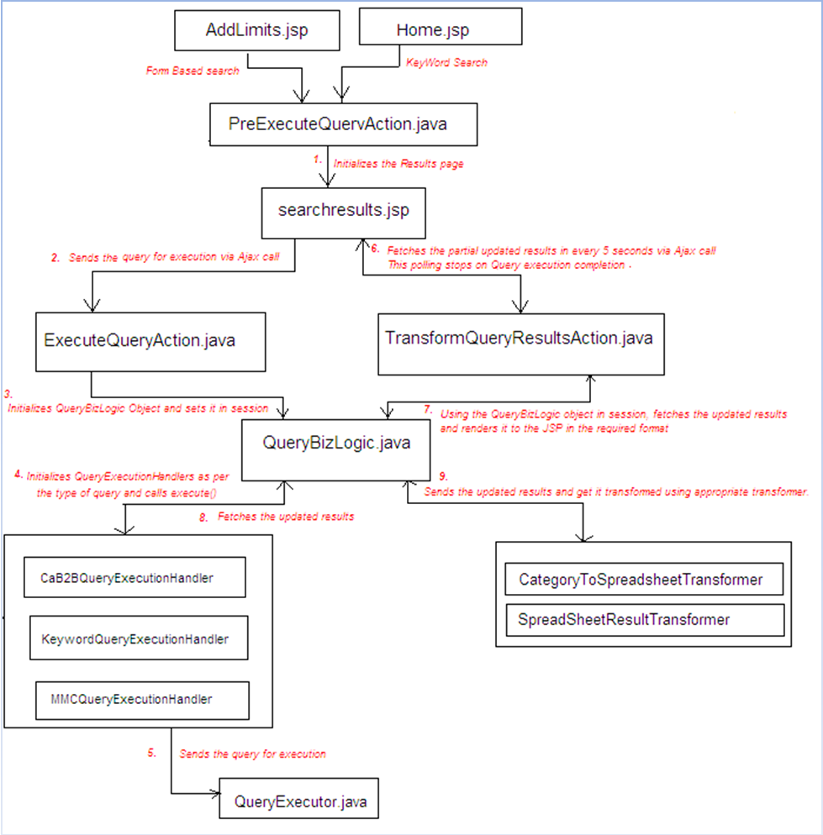
Figure 3 Query Execution Flow
Following is the summarized information about the classes, JSPs, etc used for implementing the requirements.

Result view is an Ajax driven user interface designed to improve the response time to user. UI result limit states the maximum number of results/records, UI will display on the results page. This is configurable from a properties file named “Cab2bServerProperty” through the uiResultLimit property. Having the UI result limit (say 100) ensured that server would be transforming just 100 records at max at any point of time and not more, which helps substantially in improving performance.

- PreExecuteQueryAction.java
Action class responsible for populating things needed for results page, like query parameters, dropdown for keyword search, etc. It is called at onClick () of execute button on Add Limits page and search button on home page while doing keyword search. It finds the query based on query Id. Then depending on the query type, (MMC/keyword/form based), perform above-mentioned operations. It initializes the various variables needed for the results page, to their default values. After doing all this, it directs the request to the searchresults.jsp.
- ExecuteQueryAction.java
This action class is called at onLoad() of searchresults.jsp via an Ajax call written in executeQuery() JS function of the jsp. It performs task of initializing the QueryBizLogic object and setting it in the session scope. In brief, it triggers the query for execution.
- TransformQueryResultsAction.java
After putting query on execution, this action class is called via Ajax written in getTransformedResults() JS function of the searchresults.jsp. It uses the same query by picking up the QueryBizLogic object from the session that was set by ExecuteQueryAction. It renders its output in the form of searchresultspanel.jsp. This is the main action class responsible for various UI operations like:
- Updating the results table i.e. asking the transformer to transform the results and forwarding it to the UI using searchresultspanel.jsp
- Cross checking various conditions as query finished, URLS failed, UI limit reached, etc.
- If results are more than the UI-limit, it is responsible for sub-listing the whole data as per the limit.
- On change of drop down of keyword search, the same action is called via Ajax. Based on sub-query selected, it renders the corresponding results to the UI.
- This action is called in every 5 seconds via Ajax and that too after the previous Ajax call has updated the UI. For keyword search, by default it considers the first sub-query as the selected one and renders its results.
- Continuously it polls/asks whether query execution got finished or not. Once finished, it flags the UI using STOP_AJAX session variable.
- It takes care of N*M requirement. Setting of session variables in the function updateSessionVariables(), enables and disables N*M functionality.
- Updating the various session variables like FAILED_SERVICES, SEARCH_RESULTS_VIEW, SAVED_QUERIES and request variables like TRANSFORMATION_MAX_LIMIT, QUERY_RESULT_COUNT.
- QueryBizLogic.java
It provides the various bizlogic methods used by TransformQueryResultsAction. In its constructor, it initializes the QueryExecutionHandler on the basis of query type (MMC/Keyword/ Form Based) and asks the handler to execute the query by calling it’s execute() method.

Various functions provided by QueryBizLogic are: isProcessingFinished(), setInputDataToQuery(), getSearchResults(), getFailedServiceUrls(), exportToCSV(), getStatus(), addQueryForExecuteInBackground().

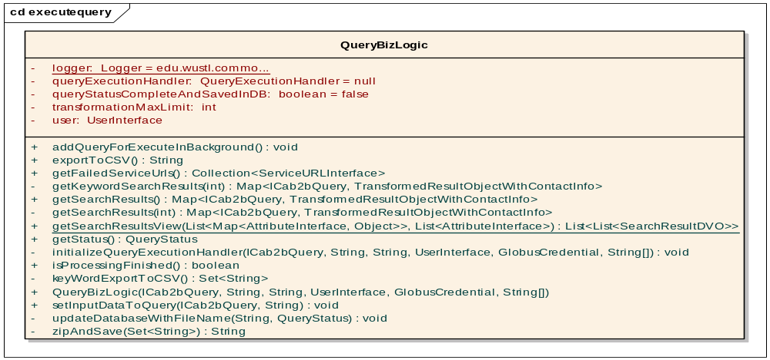
Figure 4 QueryBizLogic Class

QueryExecutionHandler
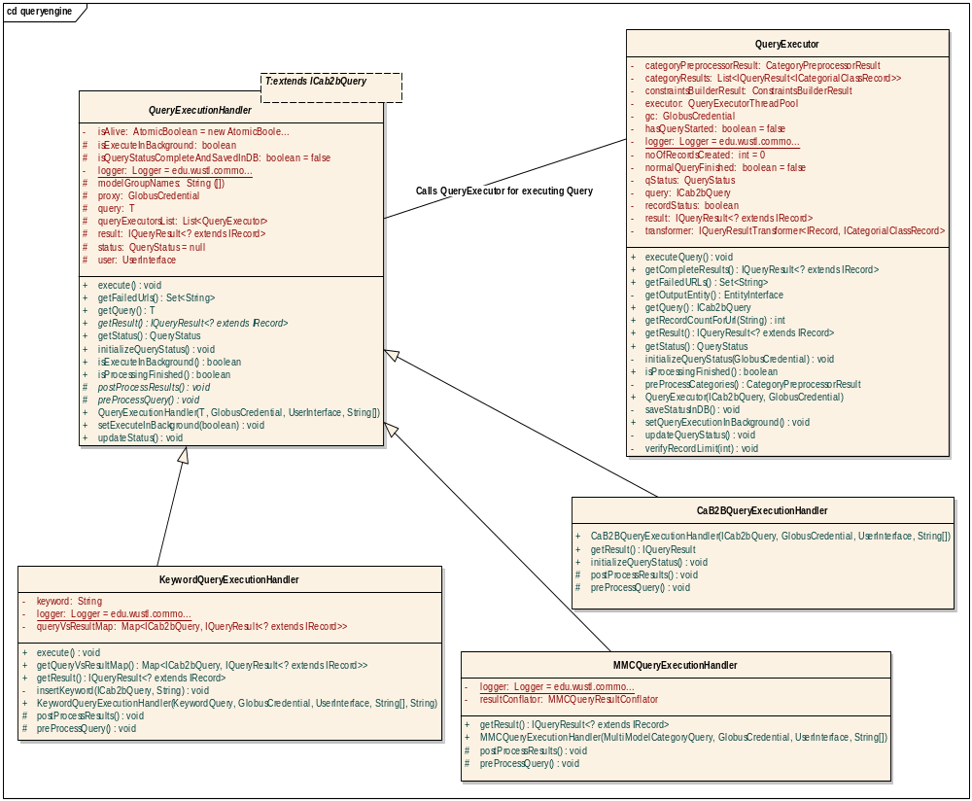
Figure 5 QuertExecutorHandler Class
It is the base class for all the query type specific handlers i.e. KeywordQueryExecutionHandler, etc. It provides basic functionalities required for query execution like execute (), getStatus (), isProcessingFinished (), updateStatus (), etc. It calls QueryExecutor class for putting the query on execution. For details about QueryExecutor, please see the design doc of query execution.

- KeywordQueryExecutionHandler.java
It extends QueryExecutionHandler and provides specific functionalities for keyword search like getQueryVsResultsMap (), preProccessQuery (), etc. All the required basic functions of base class are overridden and keyword specific functionality is performed here.
- CaB2BQueryExecutionHandler.java
It extends QueryExecutionHandler and provides specific functionalities for form based query. All the required basic functions of base class are overridden and form based functionality is performed here.
- MMCQueryExecutionHandler.java
It extends QueryExecutionHandler and provides specific functionalities for MultiModelCategory query like postProccessQuery (), preProccessQuery (), etc. All the required basic functions of base class are overridden and keyword specific functionality is performed here. It uses a MMC specific class named MMCQueryResultConflator and utilizes the conflate() function for post processing the MMC results.
- QueryExecutor.java
The main query executor class is responsible for actually putting query on execution. It is called from various execution handlers. It is responsible for updating status of query using FQP status, executing the query, storing background query’s status in DB, etc. For details about QueryExecutor, please see the design doc of query execution.
- QueryExecutorUtil.java
It is the utility class kept in the server to be used by various handlers and QueryExecutor for query execution related operations. It provides methods like getSpreadSheetRecordCount(), getEntityGroups(), etc.
- SpreadSheetResultTransformer.java
It is the transformer responsible for converting regular query (and not the category query) results to the spreadsheet records.
- CategoryToSpreadsheetTransformer.java
It is the transformer responsible for converting category query results to the spreadsheet records by counting and traversing the tree node by node and using all permutations required for making a complete record.

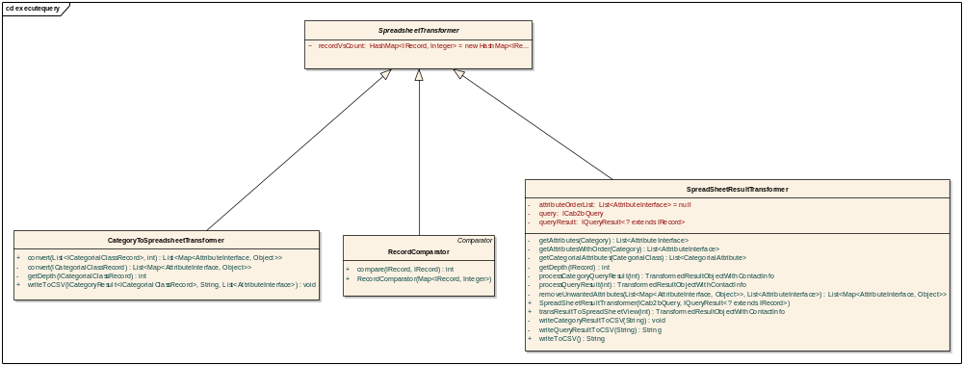
Figure 6 Transformer
- Searchresults.jsp
This JSP is responsible for the results page. It includes the searchresultspanel.jsp in one of its div. It triggers two Ajax calls at its onLoad(), one Ajax will execute the query and other one is the infinite Ajax loop continuously (every 5 seconds) polling the server ad fetching the updated results and status of the query. The JS function updateView() is the response handler function of the continuous Ajax calls here. It updates the UI view based on response got from the Ajax call in the form of searchresultspanel.jsp.

- Searchresultspanel.jsp
It is the crucial JSP responsible for carrying the response from TransformedQueryResultsAction on every Ajax call. Based on various session variables set by the action, different DIVs are created / made hidden/made visible on runtime. Function updateView() of searchresults.jsp operates on the contents of this JSP.

- Jquery.js
This JS file is utilized by the Query Parameters icon on the results page. The tool-tip created on mouse-over is built using the jquery JS.

- Ajax.js
It is the JS file responsible handling Ajax related operations like creating an Ajax request, handling its response, etc.

- Common.css
It is the base CSS class responsible for various styles applied to the searchresults.jsp.

- Searchresults.css
It contains few searchresults.jsp specific CSS functions like failedservicespanel, etc.

Query Dashboard

Overview
Query dashboard is the page where user can see the list of queries that were marked for offline execution from the search results page. Since only authenticated grid users can mark queries for offline execution, the query dashboard is visible only to the signed in user. For each offline query, the following details are shown on the dashboard:

- Query Status.
Query status can be any of the following:
- Processing
A query that has not yet completed and is under execution at a particular instance of time is shown as ‘Processing’ on the dashboard.
- Complete
A query that has successfully completed its execution without any service instance or child query failure is shown as ‘Complete’ on the dashboard.
- Complete With Error
For a query, if some results are obtained successfully but results from some service instance or class cannot be retrieved, then the query is said to be ‘Complete With Error’.
- Failed
A query from which no result could be fetched because of failure of all the service instances or the query classes itself is said to be ‘Failed’.
- Suspended
If an executing query could not be completed because of system failure, then, its status is marked as ‘Suspended’.

- Query Type
The query type can be:
- Saved Search
A form-based query when executed is shown on the dashboard with a form icon before its title so that query can be identified as form based query.
- Keyword
A keyword search is shown on the dashboard page with an icon depicting keyword before the query title so that query can be identified as a keyword query.

- Query Title.
Query title column shows the query name which has been executed.

- Result Count.
Result count column displays the number of results obtained for the query.

- Execution Date
Execution date column displays the date of query execution. This column is sorted in descending order by default.

- Action(s) – View Query Parameters and Hosting Institution Details
The action(s) column provides user the option to view query parameters and hosting institution details while user hovers on the respective icons.
Query Parameters: Query parameters overlay shows the parameters used while query execution. For a form-based query, a table is shown in the overlay with three columns, Parameter, Condition, and Value. For a keyword query, only one row is shown with Parameter as ‘Keyword Search’, Condition as ‘For’ and Value as the actual value of the keyword used while executing query.
Hosting Institution Details: Hosting institution details overlay shows a tabular view of each hosting institution on which query has been fired with its query status and result count. Status can be any of the status as applicable for an individual query.

Design
The following components are used in the functionality:

- ApplicationFilter.java
Used for checking the session validity for each request in the application.

- BackgroundQueryAction.java
This action class is called from the search results page when user clicks the ‘Offline Execution’ button. This action calls the bizlogic code for setting the appropriate parameters in the database to mark the query as background and thus visible on the dashboard page.
The following database table holds the details for offline queries:
cab2b_abstract_status (id, status, result_count, message, description)
cab2b_query_status (id, user_id, query_id, conditions, start_time, end_time, filename, parent_id, visible)
cab2b_url_status (id, url, query_status_id)

Once the query entry is made in the database, control is forwarded to the DisplayDashboardAction.java.

- DisplayDashboardAction.java
This action is called when user clicks the ‘Offline Queries’ link in the application header and also from the BackgroundQueryaction.java when a query is initially set for background execution.Query details are fetched from the database and/or memory as per requirement and set in the DVOs, QueryStatusDVO.java, ServiceInstanceDVO.java, and QueryConditionDVO.java. These DVOs represent all the view components to be displayed on the dashboard page. Along with these details, completed query count and in progress query count is set in the session that is being displayed in the dashboard link in the page header.

- QueryStatusDVO.java
This DVO class is used for representing a query executed in background. For displaying all the background-executed queries on the dashboard, a list of QueryStatusDVO.java is populated in the DisplayDashboardAction.java. This list rendered on the displaydashboardpanel.jsp.

- ServiceInstanceDVO.java
This DVO class represents a service instance on which query executed. A list of objects of this class is set for each QueryStatusDVO.java object so that service instances corresponding to each query can be displayed on the user interface.

- QueryConditionDVO.java
This DVO class represents the query conditions. An object of QueryConditionDVO.java is set for each query in QueryStatusDVO.java.
Constant Files:

- Constants.java
This is the standard application wide constant file.

Background Query Execution
With the help of caB2B, thick client user can save queries. Queries created and saved by caB2B admin user is available to all users for execution through caB2B web application. If user adds some limit, which may return large data, user has to wait for long period for getting complete data.
- UserBackgroundQueries.java
This class is used for doing operations related to background query execution. This class maintains a map of user with its queries that are currently running in background. Once query execution is completed and all results are collected, entry for the completed query is removed from the map and all information is saved in database. All methods calls for doing database operations are being called from this class. Here are some important methods and there description.
- addBackgroundQuery()
This method adds currently running query for background execution for the user and updates properties in database. Information of all queries executing is maintained in cab2b_query_status table. When query is submitted for background execution VISIBLE column of the cab2b_query_status set with true value otherwise it is always false.
- updateAllBackgroundQueryStatus()
This method updates properties like result count, url status, query status for all queries executing in background into database. This method gets called from QueryStatusUpdater class after specific time interval mentioned in BACKGROUND_QUERY_REFRESH_TIME_INTERVAL variable.
- updateBackgroundQueryStatusForUser()
This method updates properties in database for all queries executing in background only for the given user. If any background query finished its execution but if it’s exported result file is not yet generated then this method checks exported result file name in the query status object and if it’s null, it writes results into CSV file and update with file name.
- removeCompletedQueriesFromBackground()
This method removes all background queries with completed status by the user from background query map.
- getBackgroundQueriesForUser()
This method returns set of QueryStatus objects for queries working in background for the user. Please note that the set contains objects which are available in
user to background query map.
- QueryStatusUpdate.java
This class is mainly responsible for periodically updating background query status in database. Its member BACKGROUND_QUERY_REFRESH_TIME_INTERVAL decides time interval for updating database.
- refreshQueryStatus()
A background-thread calls this method is periodically and updates background query status in database.
- QueryURLStatusOperations.java
This class is responsible for saving, updating query status properties in database. It extends DefaultBizLogic and calls Hibernate actions for doing database operation. It provides following methods

Method Name | Description
insertQueryStatus | This method inserts the query status object into database.
getAllQueryStatusByUser | This method fetches all query status object for given user and query status with visible parameter as true.
getAllQueryStatusByStatus | This method fetches all query status object for given user and querystatus matching with given status parameter string.
getQueryStatusById | This method returns Query Status for given Query Status ID.
deleteQueryStatus | This method deletes the given Query Status object from database.
updateQueryStatus | This method updates the given Query Status object in database.
changeQueryStatusToAbort | This method is called at server start up and changes status to abort for all those queries and urls whose status is processing.

Exception Handling

Overview
Unhandled/unexpected exceptions in application should not cause application to crash or show cryptic error message/stack trace to the user. With this goal, on any such exception situation, the server directs the control to the global exception page showing a user-friendly message. For technical users, a small description of actual error cause is also shown.

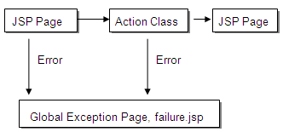
Figure 7Exception Handling Flow

Exception Handling Framework

Action Classes
In all the action classes, error prone code is surrounded by a try-catch block. In case of any unhandled/unexpected error, control goes to the catch clause. Within catch clause, ActionError and ActionErrors classes are used to set user-friendly message in request. Along with the brief error description, root cause of error is also set. All user-friendly messages are defined in the file ApplicationResources.properties. The control is then forwarded to the global exception page, failure.jsp.

JSP pages
Exceptions can occur in JSP pages also. Thus, each JSP page has a definition for its exception page, using the following tag, <%@ page errorPage="failure.jsp" %>.
- Global Exception Page, failure.jsp
The global exception page is called on any unexpected exception in application. The page has the following tag definition at top, <%@ page isErrorPage="true" %>. This makes the JVM generated exception object available to this page. Exception object is used to access detailed exception cause of the exception. User friendly message of the exception cause is shown using the Struts html errors tag. The response of failure.jsp is distinguished for AJAX and normal calls so that on failures corresponding to normal calls, entire error page with header and footer is shown but for AJAX call failures, only error message is returned without any header or footer.
- CSS file, failure.css:
This CSS file controls the page specific layout and styles of the failure.jsp page.

Index

A
Add Limit, 11
AJAX, 4, 7, 8, 12, 13, 24
B
Background Query Execution, 22
BizLogic, 2, 4
C
caB2B, 1, 2, 3, 4, 9, 11, 22
Classes, 24
CSS, 2, 4, 6, 7, 12, 19, 25
E
Exception Handling, 24
G
Global Exception, 24
J
JavaScript, 2, 4, 5, 7, 12, 13
JSP, 2, 4, 5, 6, 7, 8, 11, 12, 19, 24
Q
Query Dashboard, 20
S
Service Instances, 9
Struts, 2, 3, 4, 5, 24
V
View Results, 14

